software
requirements specification

Department of Electronics and Computer Engineering Pulchowk Campus
CORVID (Intelligent Email Processor)

VERSION: 1.0 | REVISION DATE: 24 August 2007

Approver Name | Title | Signature | Date

Contents
Section 1. Overview 1
1.1 Purpose 1
1.2 Scope 1
1.3 Target Audience 1
Section 2. Assumptions, Dependencies, Constraints 2
2.1 Assumptions 2
2.2 Dependencies 2
2.3 Constraints 2
Section 3. Requirements 3
3.1 Business Requirements 3
3.2 Functional Requirements 3
3.3 Logical Data Requirements 7
3.4 Systems Requirements 7
3.5 Interfaces 7
Section 5. References 8
Section 6. Glossary 9
Section 7. Revision History 10
Section 8. Appendices 11

Section 1. Overview

1.1 Purpose
CORVID is software that can act intelligently to help email client users manage their inbox through personalization and learning. Particularly, email client users can use it for filtering, classification and summarization of emails. CORVID tracks user’s behaviors to incoming mails and user’s feedback over CORVID actions and updates knowledgebase. Based on this knowledgebase, CORVID filters and classifies the emails. It generates summary of email threads using machine linguistic and learning techniques for summarization.

1.2 Scope
CORVID is a research based software project that consists of an extendible framework which can be extended to add new algorithms for email filtering, classification and summarization. However, only few algorithms will be implemented and it will be built as an intelligence extension to Mozilla Thunderbird.

1.3 Target Audience
Mozilla Thunderbird users can use CORVID for automated email filtering, classification and summarization.
CORVID is open source software. It consists of an extendible framework for filtering, classification and summarization of emails. Hence Mozilla Developers can use CORVID to add and test new algorithms for email filtering, classification and summarization.

Section 2. Assumptions, Dependencies, Constraints

2.1 Assumptions
Following assumptions are made regarding operations of the system:
- User provides correct feedback (as desired by the user) to the system.
- Training Dataset for filtering and classification of emails are generic.

2.2 Dependencies
The system depends on the following:
- Mozilla architecture (framework).

2.3 Constraints
The system is developed as an extension to Mozilla Thunderbird so language specified by the Mozilla layered architecture should be followed: - C++ and Javascript for module construction and XUL, Javascript, CSS for interface design.

Section 3. Requirements

3.1 Business Requirements
- Develop reliable classifier, realistic summarizer and desirable filter for all mails
- Build interactive and easy interface to use the system’s features
- Create less effort for training
- Customizable actions for above processes

3.2 Functional Requirements
3.2.1 Filtering Function
3.2.1.1 Purpose
This function is the first processing on an incoming mail. It determines if the mail is a spam mail. If the mail is a spam, it discards the mail and further processing is ceased.
3.2.1.2 Inputs
Τhe attributes of mails in the inbox are inputs to the function.
3.2.1.3 Operations
- Checks the trained profile information to determine if the mail is spam
- Updates knowledge base of the profile
3.2.1.4 Outputs
It returns a confidence factor about the spam information.

3.2.2 Classification Function
3.2.2.1 Purpose
This function classifies the incoming mails to different classes or folders using the knowledge base.

3.2.2.2 Inputs
Τhe mails in the inbox are inputs to the function and the knowledge base of the system.

3.2.2.3 Operations
- Extracts relevant features from email
- Uses knowledge base and these features to classify the mails into different folders

3.2.2.4 Outputs
It gives a classified form of inbox.

3.2.3 Summarization Function
3.2.3.1 Purpose
This function is related with generation of summary of email thread using semantic analysis and knowledge base for feature extraction.
3.2.3.2 Inputs
Τhe mails in the inbox are inputs to the function.
3.2.3.3 Operations
- Extractions of email thread using email quotation
- Determination of candidate noun phrases for summary
- Ranking the noun phrase and generating summary

3.2.3.4 Outputs
It gives a relevant summary of the threaded mail.

3.2.4 Training and Learning Functions
3.2.4.1 Purpose
This is the generalized main function of the system. It generates knowledge base using the training email corpus and reads user actions and sequences continuously to update knowledge base.
3.2.4.2 Inputs
The inputs are user actions as feedback and mail inbox.
3.2.4.3 Operations
- Tracks user action and updates knowledge base
3.2.4.4 Outputs
- It returns an updated knowledge base.

3.2.5 Interfacing Function
3.2.5.1 Purpose
This function interfaces our system with Thunderbird Client. It helps to fetch mail messages from the inbox and deals with the file system of the client.
3.2.5.3 Operations
- Interfaces CORVID’s UI to the Thunderbird UI
3.2.5.4 Outputs
- It helps in interfacing our modules with the client modules.

The use-case diagram of the system is below.

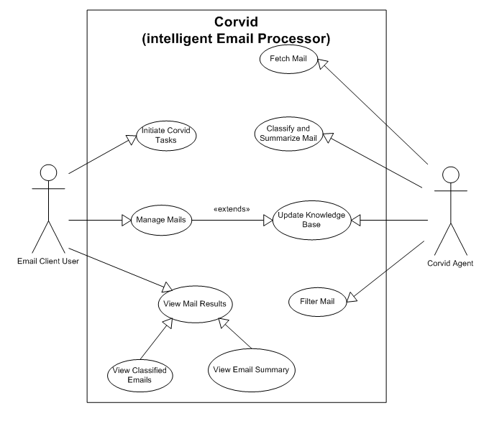
3.3 Logical Data Requirements
- Email Corpus – it is the set of trained emails used for supervised learning.
- Email Inbox: Set of emails as an input to the CORVID

3.4 Systems Requirements
3.4.1 Performance Requirements
The system response should be at most 1 second per email filtering or classification.
3.4.2 Quality Requirements
Filtering, Classification and Summarization of emails done by the system should be according to user expectation.

3.5 Interfaces
Interface between CORVID and Thunderbird communicates all other modules (Email Processing Modules) with Thunderbird. Thunderbird is developed under Mozilla Architecture. So the interface is dependent upon Mozilla Architecture.

Section 5. References

Document No. | Document Title | Date | Author
1 | A Personal Email Assistant, HP Laboratories Palo Alto, HPL-2002-236, |  | Ruth Bergman, Martin Griss, Carl Staelin
2 | Three years of Spam Mutation. In the Proceedings of The Spammer’s Compendium | January 2003 | John Graham-Cumming
3 | ifile: An Application of Machine Learning to Email Filtering. At the Artificial Intelligence Lab Massachusetts Institute of Technology, Cambridge. |  | Jason D. M. Rennie
4 | Filtron learning based antispam filter | 2004 | Eirinaios Michelakis, Ion Androutsopoulos, Georgios Paliouras1, George Sakkis, and Panagiotis  Stamatopoulos
5 | Concept Features in Re-Agent, an Intelligent Email Agent, Georgia Institute of Technology. |  | Gary Boone
6 | Combining Linguistic and Machine Learning Techniques for Email Summarization |  | Smaranda Muresan, Evelyne Tzoukermann, Judith L. Klavans

Section 6. Glossary

Corvid - member of Corvidae (family of intelligent birds). Corvids demonstrate the capacity for imagination and memorization, something that only humans were thought to possess.
Email Classification - an example of supervised learning that builds a probabilistic model of a function to map documents to classes.
Email Client - a front end computer program used to handle e-mail activities. Users can manage their inbox staying offline.
Email Corpus – Collection of emails which are organized into folders
Email Filtering - Processing of email to identify it as spam or ham mail.
E-mail spam - also known as bulk or junk e-mail is a subset of spam that involves sending nearly identical messages to numerous recipients by e-mail.
Email Summarization - Process of identifying the most salient information in an email thread conveying it in less space than the original one.
Email Thread - Reply email chain followed during email conversation between users.
Extension - act of expanding the scope of an application making it more widely available or usable.
Feature Extraction - Extraction of attributes (keywords, date, sender etc), that characterize an email.
Machine learning - design and development of algorithms and techniques that allow computers to learn.
Mozilla Architecture – architecture under which Mozilla applications such as Firefox, Thunderbird etc are built.
Mozilla Thunderbird - a free, cross-platform e-mail and news client developed by the Mozilla Foundation.

Section 7. Revision History

Version | Date | Name | Description

Section 8. Appendices

